Natural Language Processing (NLP)

MOST ASKED (Top 15 – MUST PREPARE)
- What is NLP?
- NLP pipeline?
- Tokenization?
- Stemming vs Lemmatization?
- Bag of Words vs TF-IDF?
- What are word embeddings?
- Word2Vec vs GloVe vs FastText?
- What is transformer architecture?
- What is self-attention?
- What is BERT?
- What is GPT?
- What is fine-tuning?
- What is prompt engineering?
- BLEU vs ROUGE?
15.How do you evaluate NLP models?
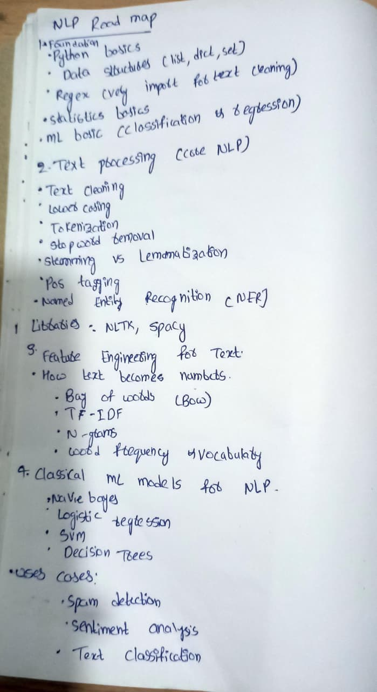
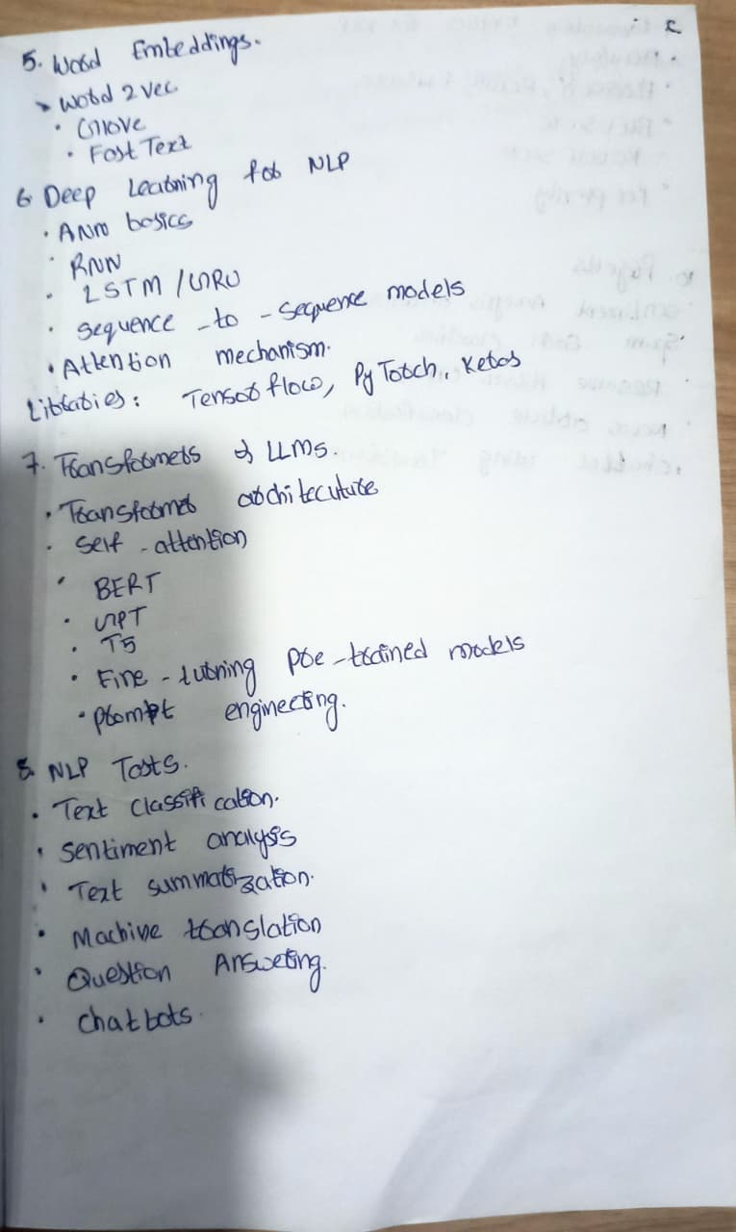
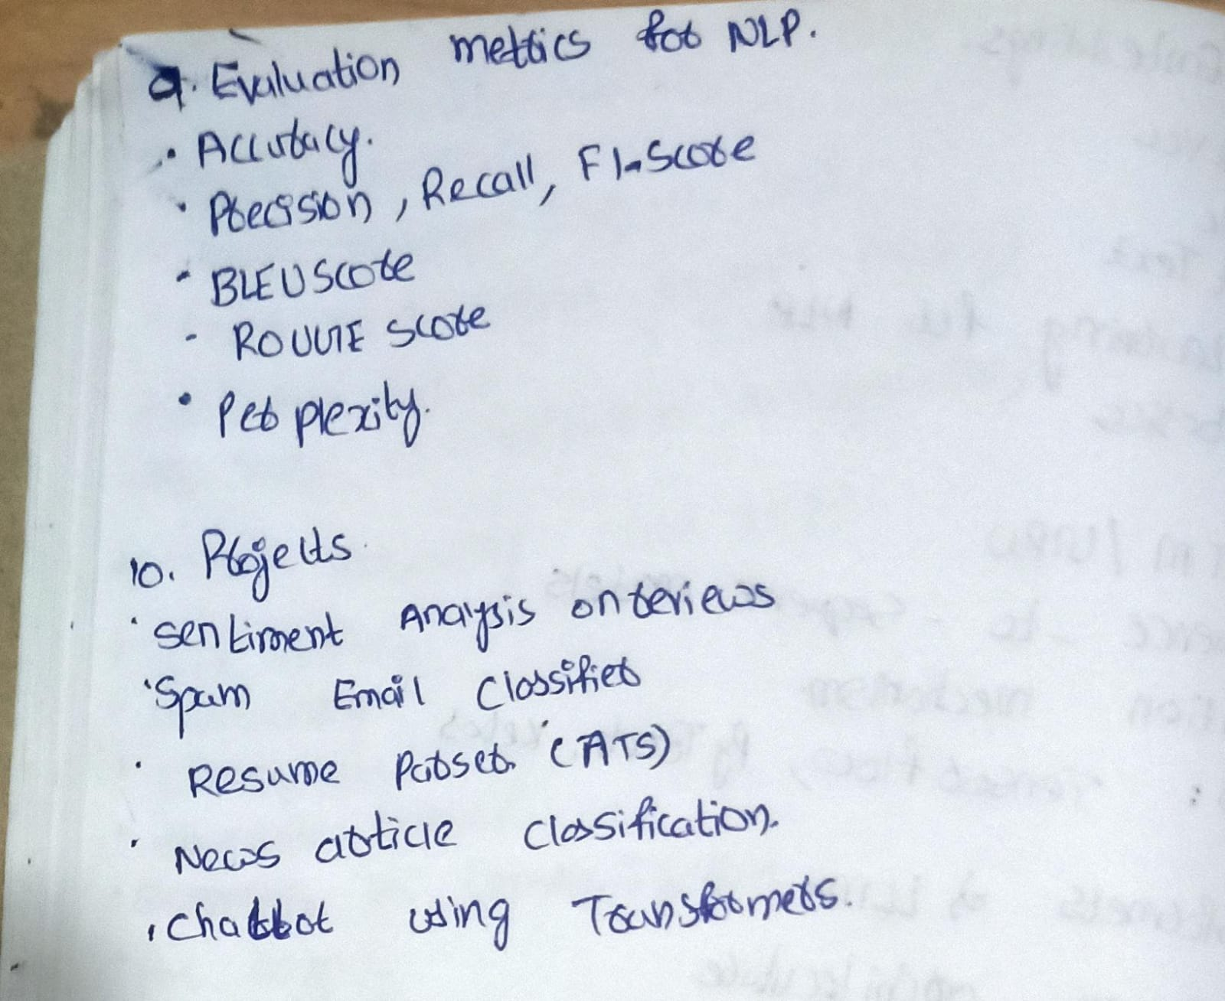
1.What is Natural Language Processing (NLP)?
Natural Language Processing (NLP) is a branch of Artificial Intelligence (AI) that enables computers to understand, interpret, process, and generate human language in both text and speech form.
It combines computer science, linguistics, and machine learning to allow machines to interact with humans in a natural way.
Examples of NLP in real life
- Chatbots & Virtual Assistants
  - Example: Customer support chatbots answering user queries automatically
  - “How can I reset my password?” → Bot gives instructions
- Sentiment Analysis
  - Example: Analyzing customer reviews on Amazon or Flipkart
  - “This product is amazing” → Positive sentiment
  - “Worst experience ever” → Negative sentiment
- Language Translation
  - Example: Translating English text to Hindi or Telugu
  - “Good Morning” → “शुभ प्रभात”
- Spam Detection
  - Example: Gmail filtering spam emails
  - “Win a free iPhone now!” → Spam
- Text Summarization
  - Example: Summarizing long news articles into short highlights
- Speech Recognition
  - Example: Voice commands in Google Assistant or Siri
  - “Set an alarm for 6 AM” → Alarm is set
2. What is Text Processing?
Text processing is the method of converting raw text into a structured and usable format so that machines can analyze it effectively in NLP tasks.
3. What is Text Cleaning?
Text cleaning is the process of removing unwanted or noisy data from text, such as punctuation, special characters, extra spaces, numbers, and irrelevant symbols.
4.What is Lower Casing?
Lower casing is the process of converting all text characters into lowercase to ensure uniformity and avoid treating the same words differently.
5. What is Tokenization?
Tokenization is the process of breaking text into smaller units called tokens, such as words or sentences, which are easier for models to analyze.
6. What is Stopword Removal?
Stopword removal is the process of eliminating commonly used words (like is, the, and, are) that do not add significant meaning to the text.
7.What is Stemming vs Lemmatization?
- Stemming
Reduces a word to its root form by cutting off suffixes, without considering grammar or meaning.
- Lemmatization
Converts a word into its base or dictionary form by considering its context and grammatical structure.
Key difference:
Stemming is faster but less accurate, while lemmatization is more accurate but computationally heavier.
8. What is POS Tagging?
Part-of-Speech (POS) tagging is an NLP technique that assigns a grammatical label (such as noun, verb, adjective, adverb, etc.) to each word in a sentence based on its context and meaning.
Why POS tagging is used (say if asked):
- Helps understand sentence structure
- Improves tasks like text parsing, NER, sentiment analysis, and machine translation
9What is Named Entity Recognition (NER)?
Named Entity Recognition (NER) is an NLP technique used to identify and classify important entities in text such as names of people, organizations, locations, dates, and monetary values.
10. What are NLTK and spaCy?
- NLTK (Natural Language Toolkit)
A Python library mainly used for learning, research, and basic NLP tasks like tokenization, stemming, and stopword removal.
- spaCy
An advanced Python NLP library designed for production-level applications, offering fast and accurate features like NER, dependency parsing, and word embeddings.
11. What is Feature Engineering for Text?
Feature engineering for text is the process of converting raw text into numerical features that machine learning models can understand and learn from.
It involves techniques like Bag of Words, TF-IDF, N-grams, and embeddings.
12. How does Text become Numbers?
Text becomes numbers by vectorization, where words or documents are converted into numerical vectors based on their frequency, importance, or context.
Common methods include Bag of Words, TF-IDF, and word embeddings.
13. What is Bag of Words (BoW)?
Bag of Words is a text representation technique where a document is represented by the frequency of words, ignoring grammar and word order.
Each document becomes a vector based on the vocabulary.
14. What is TF-IDF?
TF-IDF (Term Frequency–Inverse Document Frequency) is a feature extraction technique that measures how important a word is to a document relative to a collection of documents.
It reduces the weight of common words and increases the weight of informative words.
15. What are N-grams?
N-grams are sequences of N consecutive words or characters extracted from text.
They help capture context and word order that single words may miss.
16. What is Word Frequency & Vocabulary?
- Word Frequency
The number of times a word appears in a document or dataset.
- Vocabulary
The complete set of unique words present in the corpus used to create feature vectors.
17. Classical ML models for NLP ?
1.Navie bayes
2.Logistic Regression
3.SVM
4.Decision Trees
uses cases:
* spam detection
* Sentiment analysis
* Text classification
18. What are Word Embeddings?
Word embeddings are numerical vector representations of words that capture their meaning, context, and semantic relationships.
Unlike traditional methods, embeddings place similar words closer together in a vector space.
In short: Word embeddings convert words into meaningful numbers.
19. What is Word2Vec?
Word2Vec is a word embedding technique that learns word representations using a neural network based on the context in which words appear.
It has two main architectures:
- CBOW (Continuous Bag of Words) – predicts a word from its context
- Skip-gram – predicts surrounding words from a target word
20. What is GloVe?
GloVe
(Global Vectors for Word Representation) is a word embedding method that learns embeddings using global word co-occurrence statistics from the entire corpus.
It combines:
- Matrix factorization
- Statistical information about word relationships
GloVe captures global context, unlike Word2Vec which focuses on local context.
21. What is FastText?
FastText is a word embedding technique that represents words as a collection of character n-grams, instead of treating each word as a single unit.
This helps:
- Handle rare words
- Handle out-of-vocabulary (OOV) words
- Work well with morphologically rich languages
Quick comparison (nice to say if asked):
- Word2Vec → Learns from local context
- GloVe → Learns from global co-occurrence
- FastText → Uses subword (character-level) information
22. What is Transformer Architecture?
The Transformer architecture is a deep learning model designed for sequence data that relies on attention mechanisms instead of recurrence or convolution.
It processes all words in parallel, making it faster and more scalable than RNNs and LSTMs.
Transformers are the foundation of modern LLMs.
23. What is Self-Attention?
Self-attention is a mechanism that allows a model to focus on different words in a sentence and understand how each word relates to others.
It helps the model capture context and long-range dependencies within text.
24. What is BERT?
BERT (Bidirectional Encoder Representations from Transformers) is a transformer-based language model that understands text by looking at both left and right context simultaneously.
It is mainly used for understanding tasks like:
- Question answering
- Sentiment analysis
- Text classification
25. What is GPT?
GPT (Generative Pre-trained Transformer) is a transformer-based language model designed for text generation.
It works in an autoregressive manner, predicting the next word based on previous words, making it ideal for:
- Chatbots
- Content generation
- Code generation
26. What is T5?
T5 (Text-to-Text Transfer Transformer) treats every NLP task as a text-to-text problem, meaning both input and output are text.
This unified approach allows the same model to perform tasks like translation, summarization, and classification.
27.What is Fine-Tuning Pre-Trained Models?
Fine-tuning is the process of taking a pre-trained model and training it further on a specific task or dataset.
This helps achieve better performance with less data and training time compared to training from scratch.
28.What is Prompt Engineering?
Prompt engineering is the practice of designing effective input prompts to guide large language models to produce accurate and relevant outputs without changing model weights.
It focuses on how instructions, context, and examples are framed.
Evaluation metrics
29. What is BLEU Score?
BLEU (Bilingual Evaluation Understudy) score is an evaluation metric used to measure the quality of machine-generated text by comparing it with one or more reference texts.
It is commonly used for machine translation and is based on n-gram overlap.
Higher BLEU score = closer match to human-written text.
30. What is ROUGE Score?
ROUGE (Recall-Oriented Understudy for Gisting Evaluation) is a set of metrics used to evaluate text summarization and generation tasks.
It measures how much of the reference text is covered by the generated text, focusing mainly on recall.
Common variants:
- ROUGE-1 → unigram overlap
- ROUGE-2 → bigram overlap
- ROUGE-L → longest common subsequence
31. 3. What is Perplexity?
Perplexity is a metric used to evaluate language models by measuring how well a model predicts the next word in a sequence.
It reflects the model’s uncertainty:
- Lower perplexity → better language model
- Higher perplexity → more uncertainty
PART 1: Important NLP Questions You’re Missing (with short interview-ready answers)
These are commonly asked and should be added to your notes.

32. What is a Corpus?
A corpus is a large collection of text documents used for training and evaluating NLP models.

33. What is a Document-Term Matrix (DTM)?
A Document-Term Matrix is a matrix where rows represent documents, columns represent words, and values represent word frequency or TF-IDF scores.

34. What is OOV (Out-of-Vocabulary) Problem?
The OOV problem occurs when a model encounters words during testing that were not seen during training.
FastText and subword embeddings help solve this issue.

35. What is Padding and Truncation?
- Padding adds extra tokens to make all sequences the same length
- Truncation cuts longer sequences to a fixed length
Used mainly in deep learning and transformers.

36. What is Sequence-to-Sequence (Seq2Seq) Model?
A Seq2Seq model maps an input sequence to an output sequence using an encoder-decoder architecture.
Used in translation, summarization, and chatbots.

37. What is Attention vs Self-Attention?
- Attention → Focuses on relevant parts of input during decoding
- Self-attention → A word attends to other words in the same sentence

38. What is Encoder and Decoder in Transformers?
- Encoder → Understands input text (BERT)
- Decoder → Generates output text (GPT)
- Encoder–Decoder → Does both (T5)

39. What is Context Window?
The context window is the maximum number of tokens a language model can process at one time.

40. What is Hallucination in LLMs?
Hallucination occurs when an LLM generates confident but incorrect or fabricated information.

41. What is Zero-shot and Few-shot Learning?
- Zero-shot → No examples given
- Few-shot → A few examples included in the prompt
Used heavily in prompt engineering.

42. What is Transfer Learning in NLP?
Using knowledge from a pre-trained language model and applying it to a new NLP task.

43. What is Overfitting in NLP Models?
When a model performs well on training data but poorly on unseen text.

44. What is Class Imbalance in Text Classification?
When some text classes have significantly more samples than others, affecting model performance.

45. What is Explainability in NLP?
The ability to understand why a model made a particular prediction, important in real-world applications.

